Project Plan

**Sydney Airbnb**

Student Names

Sabin Luitel

S5275468

Suzan Shrestha

S5279574

Rayan ⁠chang Hee Kim

s5188533

Table of Contents

1.0 Introduction 3

1.1 Background 3

1.2 Scope 3

1.3 Document contents 3

2.0 Work Breakdown Structure 4

3.0 Activity Definition & Estimation 5

4.0 Gantt Chart 6

# Introduction

This report gives a summary of the Airbnb Sydney dataset, which details the listing activity of homestays in Sydney, New South Wales, Australia. The information is updated every month as part of the Inside Airbnb effort. This report will provide an overview of the problem context, scope, and document contents in relation to this dataset.

## Background

Since 2016, Sydney has been one of the top cities in the world for Airbnb listings. In-depth information on listings, calendar data, reviews, neighbourhood data, and summary metrics have all been gathered to better learn this trend and examine the mechanics of the Sydney Airbnb industry. To better understand Sydney's hospitality sector, this dataset offers a useful resource for a range of stakeholders, including scholars, lawmakers, and Airbnb hosts.

## Scope

This report's objective is to give a general overview of the Airbnb Sydney dataset. It gives an overview of how this data may be utilised for research and visualisation as well as a summary of the data types and their contents.

## Document contents

Sydney has been among the top cities in the world for Airbnb listings since 2016. This dataset, which was made accessible as part of the Inside Airbnb effort, contains a wealth of data about Sydney's homestay listing activity. Understanding this dataset can help us gain knowledge about the dynamics of the homestay industry, price patterns, host behaviour, and the overall effect of Airbnb on the city's housing stock.

This document is structured to cover following areas:

1. Work Breakdown structure

On this section involved the major task and activities in working with Airbnb Sydney dataset. A WBS helps to manage and organize the project.

1. Activity Definition & Estimation

The activity Definition and Estimation defines each activity and estimates the required time of completion and helps to provide established days.

1. Gantt chart

Gantt chart virtually presents the project timeline based on the duration of each activity. This chart helps in assessing project management and tracking progress.

# Work Breakdown Structure

We will describe the main roles and actions involved in working with the Airbnb Sydney dataset in this section. A hierarchical representation of the project duties is provided by the work breakdown structure (WBS).

# Activity Definition & Estimation

Here are the specified tasks necessary for your project, along with estimates for how long each action could take, based on the submitted Work Breakdown Structure (WBS):

1. Planning
   1. Project Plan (36 days)
   2. Scope (4 days)
   3. WBS (2 day)
   4. Activity Definition (2 day)
   5. Scheduling and Gantt chart (3 days)
2. Software Design Document
   1. System Vision (5 days)
   2. Formal Requirements (6 days)
   3. Use Cases (3 days)
   4. Software Design / Components (7 days)
   5. Interface Design (4 days)
3. Implementation
   1. Test Report (3 days)
   2. Data Processing (7 days)
   3. User Defined Data Recall (6 days)
   4. Data Visualization (6 days)
   5. GUI Implementation (9 days)
4. Controlling
   1. Progress Meetings (4 days)
   2. Status Reports (3 days)
   3. Update Plans (3 days)
   4. Update Schedule (2 days)
   5. Version Control (2 day)
5. Closing
   1. Executive Summary (3 days)
   2. User Manual (6 days)
   3. Self-Assessment of Schedule (2 day)

The accuracy of these time estimates will depend on the resources available to the project as well as the complicated nature of each activity. As the project progresses and we obtain a better idea of the real-time needed for each action, it is crucial to review and revise these estimates. Your Gantt chart, which will give a visual depiction of the project timetable, will be made using these activities.

# Gantt Chart

Based on the expected durations for each task, the Gantt chart below illustrates the project timeframe. About 60 days are needed to complete the job.

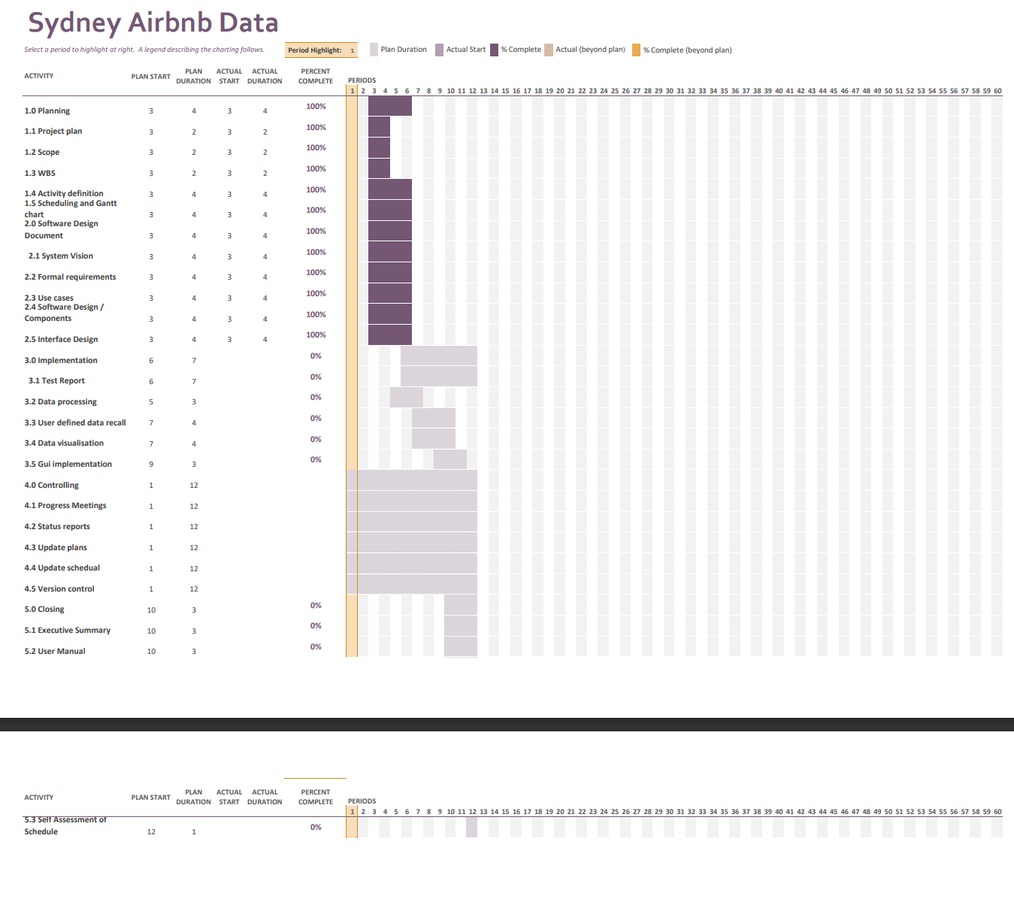

The Gantt chart shows how tasks are to be completed and their dependencies, enabling effective project control and monitoring performance. The chart is also useful for effectively organising and imparting resources to fulfil project deadlines.